1:1 VERIFICATION SERVICES FOR KISAN CARD

Kissan Cards will be issued to farmers benefiting from the Khyber Pakhtunkhwa government programmes. It aims to consolidate recipient’s information for transparent and efficient implementation of these interventions. KP IT Board is being developed a digital platform and would be provided to all district administrations with user logins to enter details of farmers in their jurisdictions. The information added to the system pertains to demographics, contact details, crops and landholding patterns, livestock, irrigation system and mechanization.

This initiative will result in appropriate allocation of schemes to the right farmers, ease in broadcasting message to the larger mass and the creation of a centralized database.





How does 1:1 Verification works?
CAPTURE
ASSESS
MONITOR
REACT
Obtains facial images from still image storage (mobile cameras, smart devices and digital databases)
Assesses individual still images, detects faces and analyzes each face to determine its unique facial signature.

Creates a small template for each unique face.
Compares each template image against CNIC image until a match is found.

Maintains a history of matches.
Allows configuration of real-time alerts to be appeared as pop-up on the mobile screen in case of matched or not-matched.

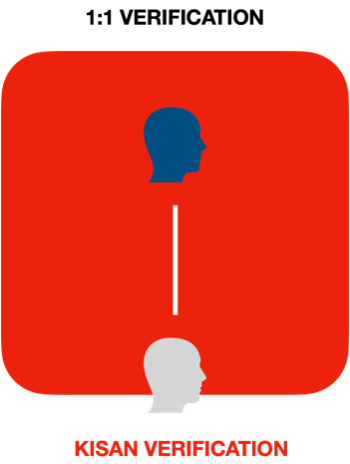

1:1 Verification will be used to authenticate & verify the Kisan’s credential prior to provide benefits regarding agriculture.

Process Flow

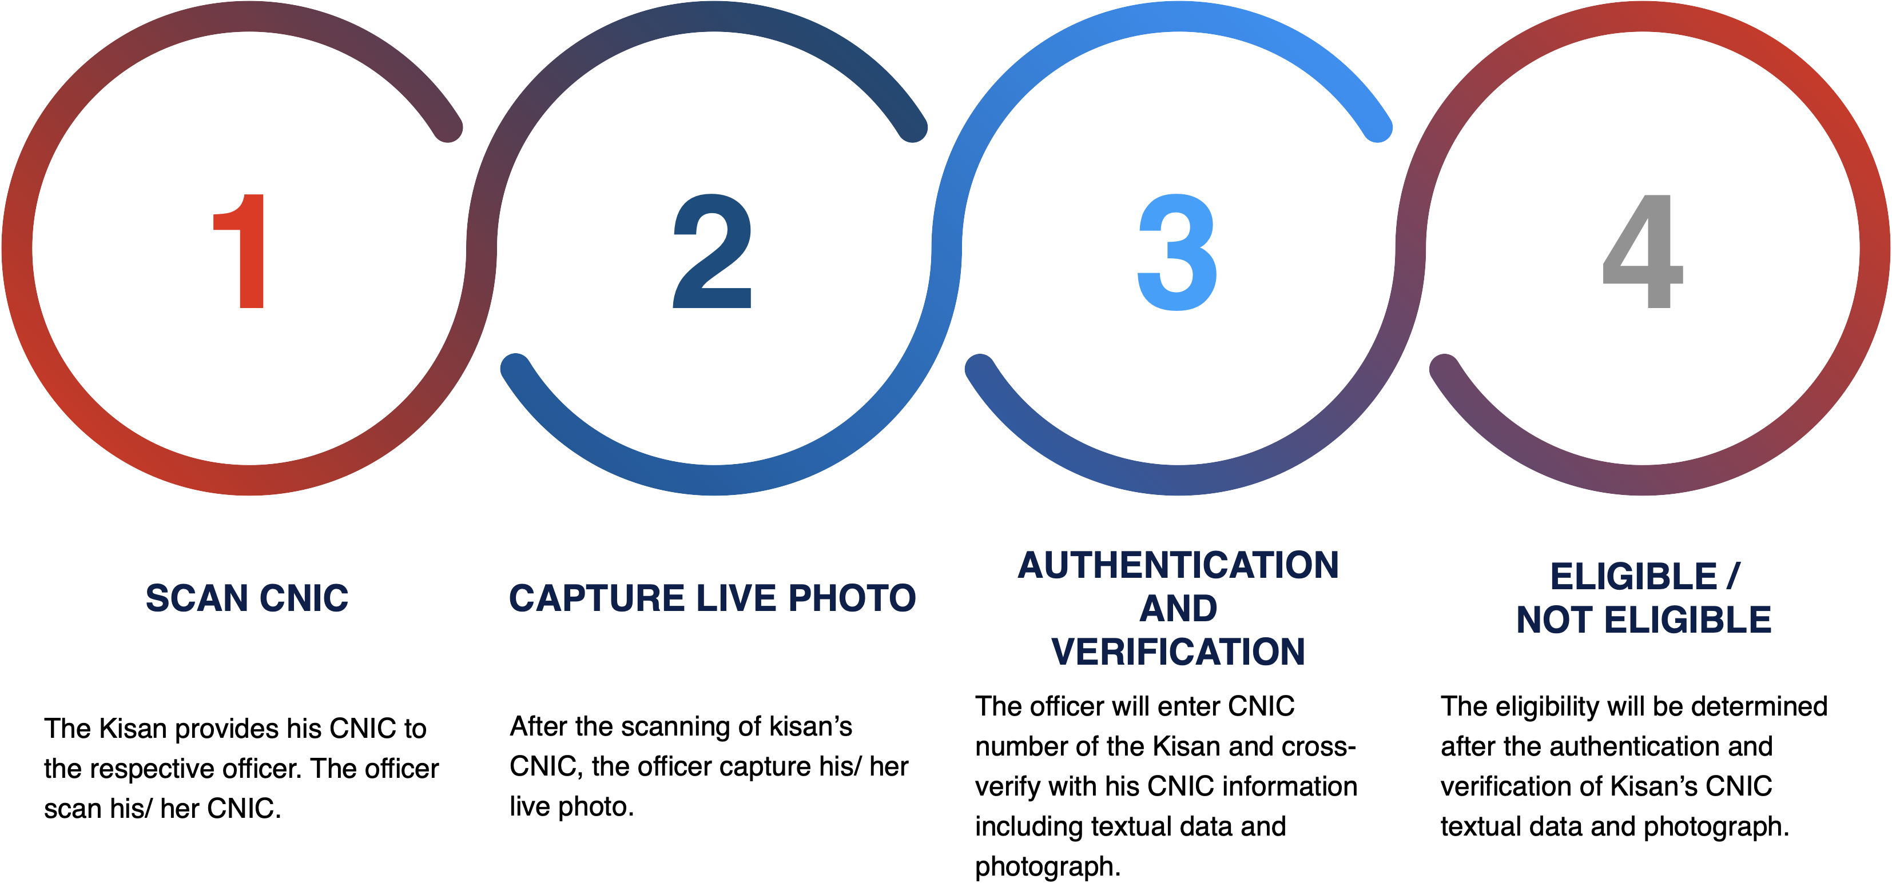

User Journey

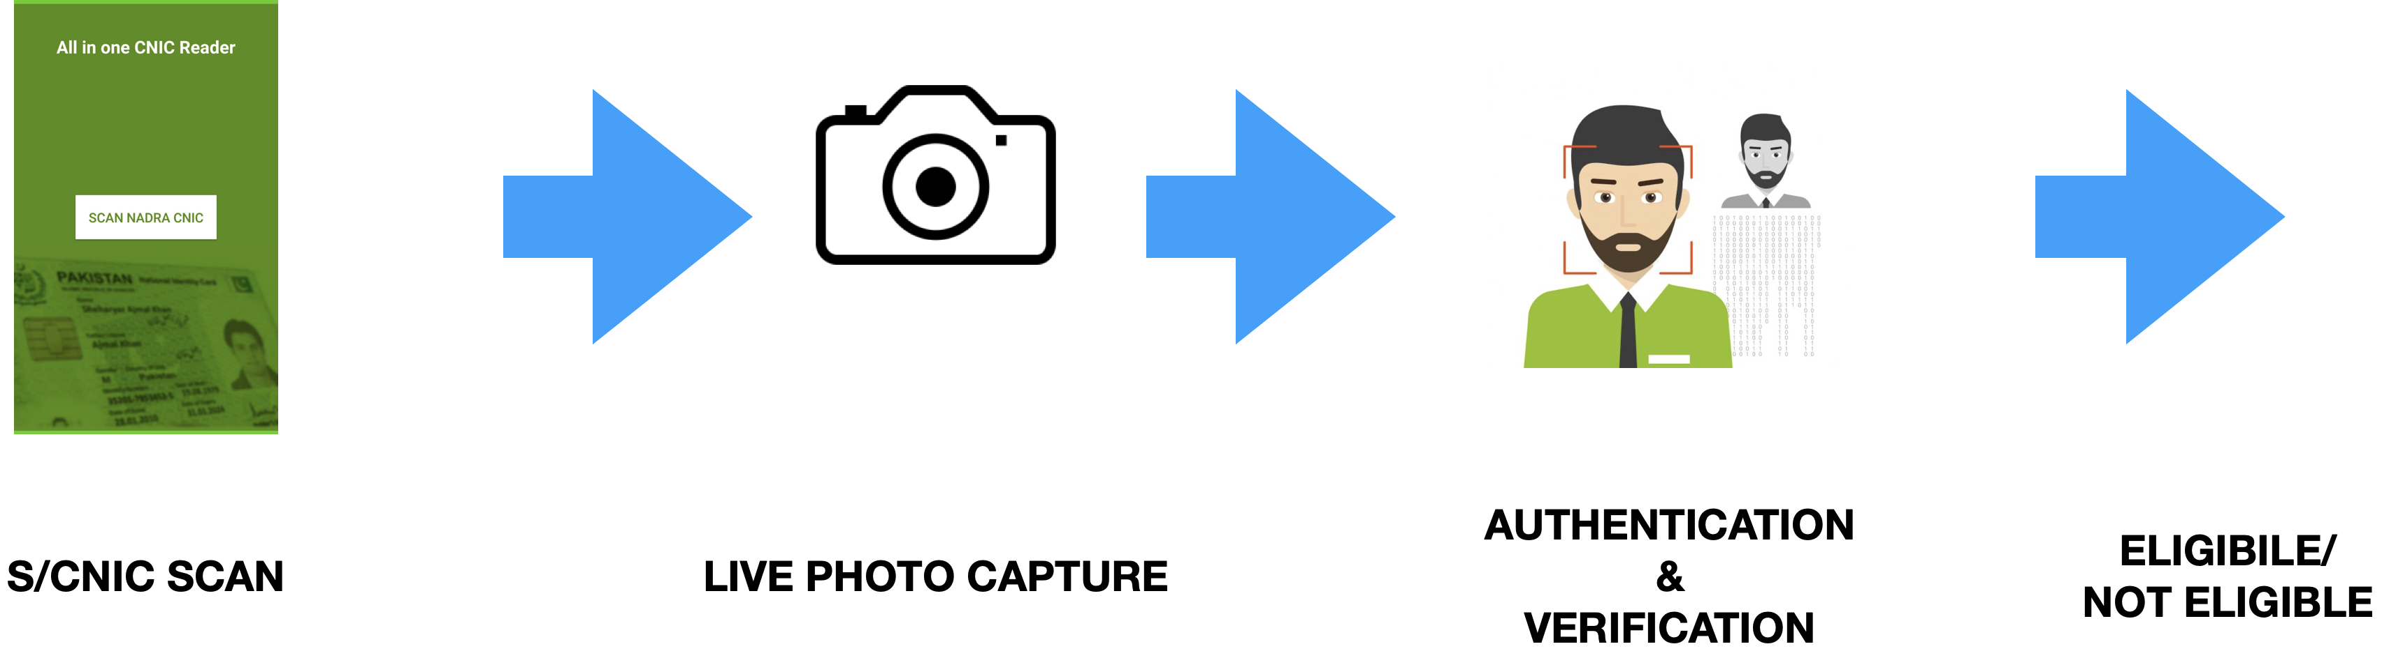
Kisan Credential Verification

DTC will provide facial verification services for above highlighted processes. The following non-technical and technical steps will be carried out:
- Operator/ Vendor will scan/ capture customer CNIC using cell phone camera.
- Operator will than capture a frontal face photograph of the customer.
- The developed app may then query DTC 1:1 Facial Verification Service using a RESTful API Request in which both captured images will be attached along with some meta-data.
- DTC Service will first validate both images for correctness (brightness, pose, CNIC quality etc.).
- If either image is incorrect/ invalid an invalid response will be returned and operator may be asked to re capture concerned Image.
- Upon validity confirmation, DTC Service will crop and extract faces from the captured images.
- These faces will then be compared.
- DTC will return status of matched/unmatched.

Technical Details

DTC facial verification services use deep learning-based model to extract uniquely identifiable features from facial images. These features are than compared to compute a confidence measure. Based on a set threshold and the computed confidence the status of matched or unmatched is returned. The system is enveloped in a Restful API making it easy for third party developers to integrate facial verification system into their own applications.

- Face detection & tracking
Quickly and accurately detect the face printed on the Card as the card is scanned on the live picture is captured and process for matching. If the data was stored in the database, the relevant information of card holder would also be able to fetch.

- Accurate Localization of Facial Feature Points
DTC solution will locate the key feature points on the face in the frame captured from Kisan Care (such as eyes, nose, mouth, etc.), used to determine the face posture and face alignment from real time captured image.

- Face image quality assessment
A quality threshold can be used during face enrolment to ensure that only the qualified face template will be stored into database to decrease the effect of image quality on matching performance.

- Face identification capability
It can be used for fast matching in 1:1 mode (verification) for cardholder verification, as well as 1:N (n= large database size) mode (identification) for reporting and analysis purpose.
1:1 and 1:N capabilities can be utilized in separate but integrate able solution of DTC which financial aspect treated separately as well.
It can also verify if it's same person by calculates two faces's similarity based on features extraction. If the matching score is higher than the pre-defined facial matching threshold then the input template is said to have successfully matched with the stored template.

